**Assignments -- 11th April**

**1.What is a protocol?**

protocol,is **a set of rules or procedures for transmitting data between electronic devices, such as computers**. In order for computers to exchange information, there must be a preexisting agreement as to how the information will be structured and how each side will send and receive it

**2.What is OSI Model?**

The OSI provides a standard for different computer systems to be able to communicate with each other.

The OSI Model can be seen as a universal language for computer networking. It’s based on the concept of splitting up a communication system into seven abstract layers, ea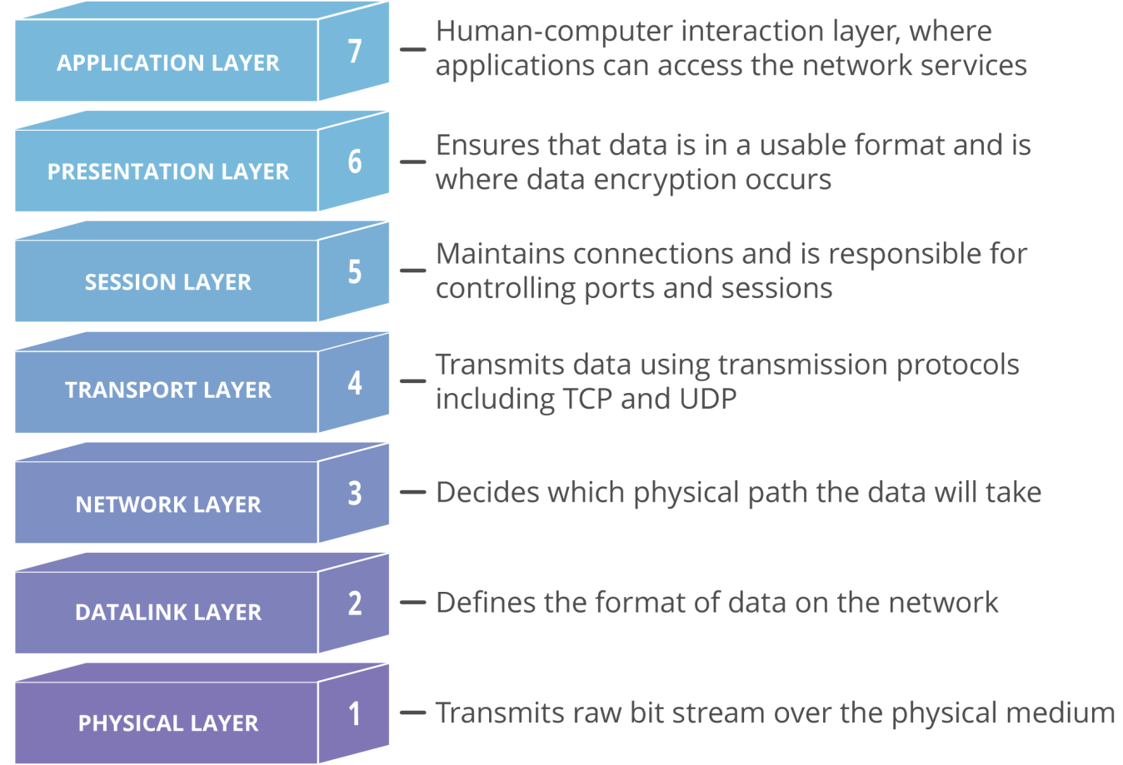

**What is TCP/IP Model?**

****TCP/IP Model**** helps you to determine how a specific computer should be connected to the internet and how data should be transmitted between them. It helps you to create a virtual network when multiple computer networks are connected together. The purpose of TCP/IP model is to allow communication over large distances.

TCP/IP stands for Transmission Control Protocol/ Internet Protocol.

Application Layer

Transport Layer

Internet Layer

Network Access Layer

**What is the difference between OSI Model and TCP/IP Model?**

|  |  |
| --- | --- |
| OSI represents ****Open System Interconnection****. | TCP/IP model represents the Transmission Control Protocol / Internet Protocol. |
| OSI is a generic, protocol independent standard. It is acting as an interaction gateway between the network and the final-user. | TCP/IP model depends on standard protocols about which the computer network has created. It is a connection protocol that assigns the network of hosts over the internet. |
| The OSI model was developed first, and then protocols were created to fit the network architecture’s needs. | The protocols were created first and then built the TCP/IP model. |
| It provides quality services. | It does not provide quality services. |
| The OSI model represents defines administration, interfaces and conventions. It describes clearly which layer provides services. | It does not mention the services, interfaces, and protocols. |
| The protocols of the OSI model are better unseen and can be returned with another appropriate protocol quickly. | The TCP/IP model protocols are not hidden, and we cannot fit a new protocol stack in it. |
| It is difficult as distinguished to TCP/IP. | It is simpler than OSI. |
| It provides both connection and connectionless oriented transmission in the network layer; however, only connection-oriented transmission in the transport layer. | It provides connectionless transmission in the network layer and supports connecting and connectionless-oriented transmission in the transport layer. |
| It uses a horizontal approach. | It uses a vertical approach. |
| The smallest size of the OSI header is 5 bytes. | The smallest size of the TCP/IP header is 20 bytes. |
| Protocols are unknown in the OSI model and are returned while the technology modifies. | In TCP/IP, returning protocol is not difficult. |

**What is http?**

**HTTP** stands for **H**yper **T**ext **T**ransfer **P**rotocol

**What is https?**

Hypertext transfer protocol secure (HTTPS) is the secure version of [HTTP](https://www.cloudflare.com/learning/ddos/glossary/hypertext-transfer-protocol-http/), which is the primary protocol used to send data between a web browser and a website. HTTPS is encrypted in order to increase security of data transfer. This is particularly important when users transmit sensitive data, such as by logging into a bank account, email service, or health insurance provider.

**What is SSL?**

SSL stands for Secure Sockets Layer and, in short, it's the standard technology for keeping an internet connection secure and safeguarding any sensitive data that is being sent between two systems, preventing criminals from reading and modifying any information transferred, including potential personal details

**What is Encryption?**

Encryption is **a process that scrambles readable text so it can only be read by the person who has the secret code, or decryption key**. It helps provide data security for sensitive information

**What is Decryption?**

Definition: **The conversion of encrypted data into its original form** is called Decryption. It is generally a reverse process of encryption. It decodes the encrypted information so that an authorized user can only decrypt the data because decryption requires a secret key or password.

**What is DNS?**

The domain name system (DNS) is **a naming database in which internet domain names are located and translated into Internet Protocol (IP) addresses**. The domain name system maps the name people use to locate a website to the IP address that a computer uses to locate that website.

**What is a Router?**

A router **takes data packets from devices and directs them to the right place**. Routers often use IP addresses to know where to look for information. Routers allow your computers to access the internet or request files from a server. It also makes sure that information goes back to the device that requested it

**What is ISP and what do they do?**

ISP stands for Internet Service Provider. An Internet Service Provider is a company that provides Internet access to organizations and home users.

In short, an ISP provides you with Internet access, usually for a fee. Without an ISP, you wouldn’t be able to shop online, access Facebook, or read this page. Connecting to the Internet requires specific telecommunications, networking, and routing equipment. ISPs allow users access to networks that contain the required equipment, enabling users to establish Internet connectivity.

ISPs are responsible for making sure you can access the Internet, routing Internet traffic, resolving domain names, and maintaining the network infrastructure that makes Internet access possible.

While the core function of an ISP is to provide Internet access, many ISPs do much more. ISPs also offer services like web hosting, domain name registration, and email services.